
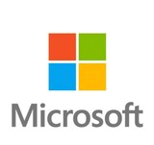
Equity Research Report
Microsoft Corporation (NASDAQ:MFST)
September 2025
Current Price  $501.01 | Target Price  $615.38 | Potential Upside Reccomendation  22.8% Buy | Industry  Software - Infrastructure
 |  | Investment Thesis
We suggest a Buy recommendation on Microsoft Corporation (NASDAQ:MFST) based on a yearly price target of $615.38, showing an upside potential of 22.8% from its closing price of $501.01 on 11/09/2025. These key points drive our suggestion:
Relative Valuation
Microsoft appears somewhat overvalued compared to key tech peers like Alphabet, Adobe, and Oracle, trading at elevated multiples with a P/E of 36.73x and EV/EBITDA of 23.04x, both above sector medians. Its P/S ratio of 13.28 also significantly exceeds peers such as Alphabet at 7.98 and Adobe at 6.81, indicating high investor expectations. Some financial sources highlight that Microsoft trades at higher multiples than its historical averages, raising concerns about overvaluation.
However, arguments for Microsoft’s fair or even undervalued status also exist. Its leadership in cloud computing, expansion into AI with products like Copilot, and strategic acquisitions such as Activision Blizzard position the company well for long-term growth in. a rapidly expanding total addressable market. Analyst sentiment remains largely positive, with maintaining moderate buy ratings and raising price targets, reflecting confidence in Microsoft’s future prospects. Ultimately, the premium valuation reflects investors paying for a diversified portfolio, market leadership, and innovation, but with that comes heightened expectations and reduced margin for error amid macroeconomic and geopolitical uncertainties.
Microsoft’s Pipeline, Acquisitions, and International Expansion
Microsoft is expanding its European datacenter footprint by 40% over the next two years, more than doubling capacity between 2023 and 2027, with over 200 data centres planned across 16 countries. It supports a broad AI and cloud ecosystem, including sovereign cloud partnerships in France and Germany that operate under local control, plus collaborations with European cloud providers to tailor services to regional needs. The company’s Digital Resilience Commitment guarantees uninterrupted cloud operations in Europe even amid geopolitical risks, backed by legal protections and contingency plans.
Microsoft plays a critical role in Europe’s cybersecurity, providing ongoing support against cyber threats and appointing a Deputy CISO for Europe to ensure compliance with regulations like DORA and the Cyber Resilience Act. Its open AI and cloud access principles support over 1,800 AI models, including many open source, empowering European startups and enterprises to innovate across industries. Committed to respecting European laws and values, Microsoft partners broadly across the continent to strengthen digital infrastructure, economic competitiveness, and resilience, solidifying its leadership in Europe’s technology landscape.

Strategic Realignment and Operational Focus
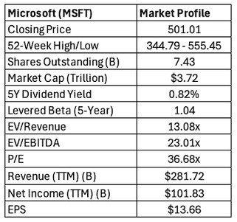
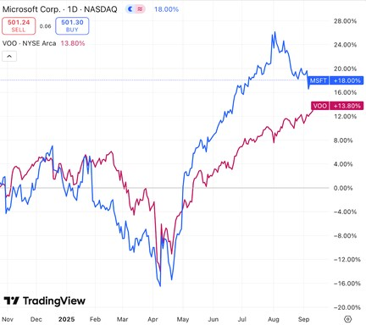
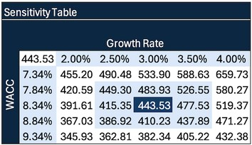
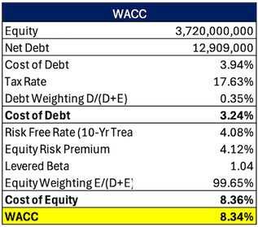
Microsoft is aggressively expanding its Azure cloud platform while deeply integrating AI technologies across its entire product stack, including Microsoft 365 Copilot and tailored cloud solutions for specific industries. The company is also optimising legacy business segments to improve profitability, all while investing heavily in new innovation cycles and forming strategic partnerships with AI startups to sustain growth and enhance margins. Operational efficiency is being boosted through streamlined sales processes and rigorous cost management efforts. Microsoft’s clear goal is to accelerate AI adoption across enterprises and government sectors, positioning itself as a key driver of long term value creation in the evolving digital economy.

News and Potential Risks
Microsoft CEO Satya Nadella recently acknowledged the need to improve employee relations following multiple rounds of layoffs and a new hybrid work mandate requiring office attendance three days a week. In an online meeting, Nadella addressed concerns about a perceived lack of empathy in the company culture and emphasised the leadership team’s commitment to doing better. Despite internal challenges, Microsoft’s financial perfomance remains strong, with Azure cloud growth of 39% and a 24% increase in net income reported in July, pushing its market value to $3.7 trillion

Equity Research Report
Microsoft Corporation (NASDAQ:MSFT) Company & Industry Overview

Company Overview
Microsoft Corporation is a global technology leader headquartered in Redmond, Washington, founded in 1975. With operations in over 190 countries, the company develops and sells software, hardware, and cloud-based solutions that serve both consumers and enterprises. Its product suite includes Azure, Microsoft 365, Windows, LinkedIn. GitHub, Dynamics 365, and Xbox. Microsoft’s transformation into a cloud-first, AI-driven platform company has positioned it at the centre of global digital infrastructure and enterprise innovation

Leadership
Satya Nadella, appointed CEO in 2014, has been instrumental in transforming Microsoft’s culture, strategic vision, and competitive positioning. Under his leadership, Microsft shifted from a product centric competitive culture to one built around collaboration, empathy, and a growth mindset, empowering employees to become “learn it alls” instead of “know it alls.” Nadella emphasised cultural renewal alongside a bold strategic pivot toward cloud computing, AI, and enterprise integration, repositioning Microsoft as a leader in business transformation. He championed major acquisitions such as LinkedIn, GitHub, and Activision Blizzard to deepen Microsoft’s ecosystem, and under his stewardship, Azure has grown into a multi billion dollar cloud platform that is now central to the company’s business. Nadella’s leadership style, rooted in empathy and innovation, has restored Microsoft’s relevance in a hyper competitive tech landscape and positioned it for continued success in the AI driven era.

R&D Strategy
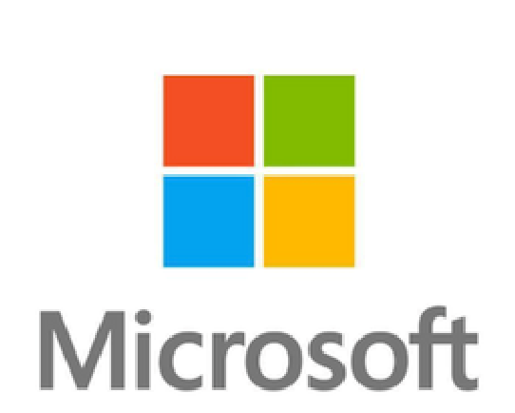
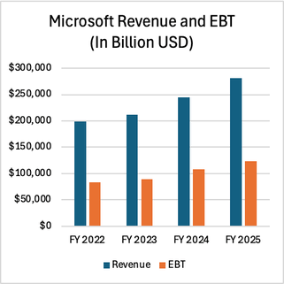
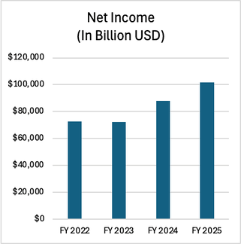
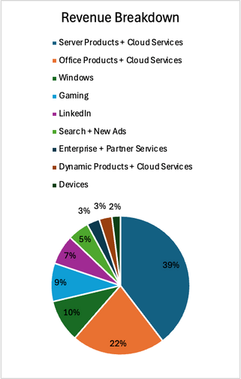
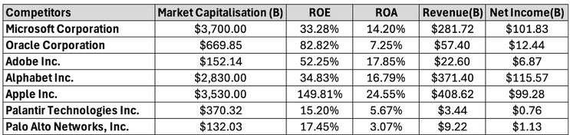
Microsoft maintains one of the world’s most aggressive and diversified R&D programs, investing over $25 billion annually to drive innovation across cloud infrastructure, artificial intelligence, productivity tools, and developer platforms. The company’s research strategy is built on rapid iteration, scalable deployment, and long term bets, with a strong emphasis on customer feedback and responsible AI principles. Its flagship AI initiatives such as Microsoft 365 Copilot, GitHub Copilot, and Azure OpenAI Services have introduced generative AI capabilities at scale, enhancing productivity, software development, and enterprise decision making. Microsoft Research continues to contribute cutting edge advancements in machine learning, security, natural language processing, and quantum computing. By integrating innovation deeply across its product suite and focusing on seamless cloud and AI convergence, Microsoft has positioned itself not just as a software provider but as a critical enabler of digital transformation across industries.

Recent Performance & Key Developments
Microsoft’s FY25 results underscore strong growth fueld by cloud and AI, with revenue reaching $281.7 billion, up 15% YoY. Operating income rose 17% to $128.5 billion, and net income increased 16% to $101.8 billion. In Q4 alone, Microsoft Cloud revenue climbed 27% YoY to $46.7 billion, driven by a 34% increase in Azure revenue. The Productivity and Business Processes and Intelligent Cloud segments delivered double digit growth, supported by steady Perfomance in personal computing and gaming. Microsft returned $9.4 billion to shareholdres through dividends and buybacks, reflecting strong cash flow and continued focus on shareholder returns.

Industry Overview
As of September 2025, Microsoft Corporation (NASDAQ:MSFT) is valued at approximately $3.7 trillion in equity. Its closest peers by equity value include:
Apple Inc. (AAPL) - Equity Value: $3.53 trillion
Alphabet Inc. (GOOG) - Equity Value : $2.83 trillion
Oracle Corporation (ORCL) - Equity Value: $669.85 billion
Palantir Technologies Inc. (PLTR) - Equity Value $370.32 billion
Adobe Inc. (ADBE) - Equity Value: $152.14 billion
Palo Alto Networks, Inc. (PANW) - Equity Value: $132.03 billion
Each competing in overlapping segments such as cloud infrastructure, AI, cybersecurity, and productivity software. The broader industry is defined by rapid shifts toward generative AI, integrated cloud platforms, and secure digital ecosystems. Enterprise demand continues to rise for scalable, date driven solutions that span infrastructure, software, and analytics. Competitors are investing aggressively to capture this growth. As consolidation and innovation reshape the space, scale, ecosystem depth, and platform integration have become key differentiators among top players.
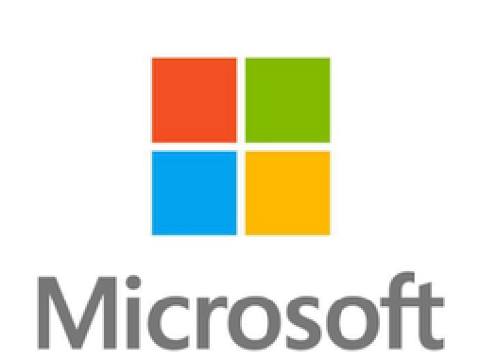
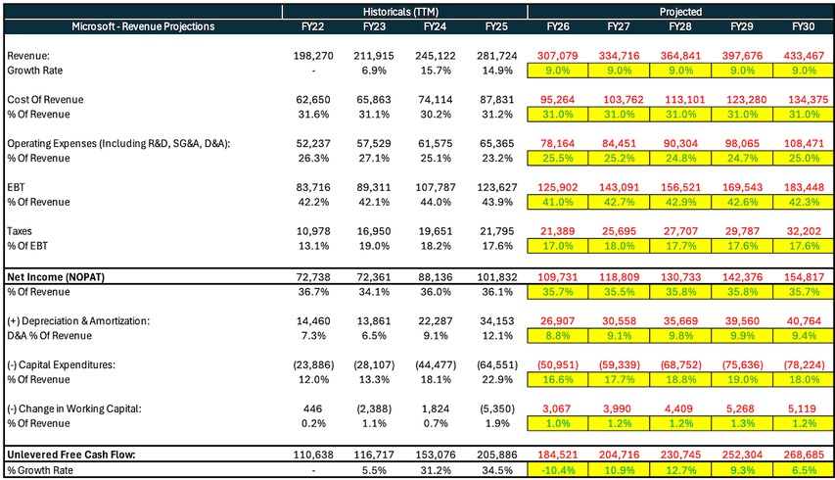
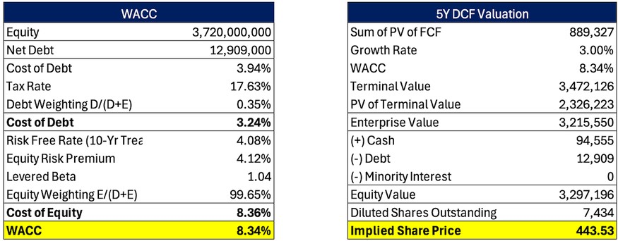
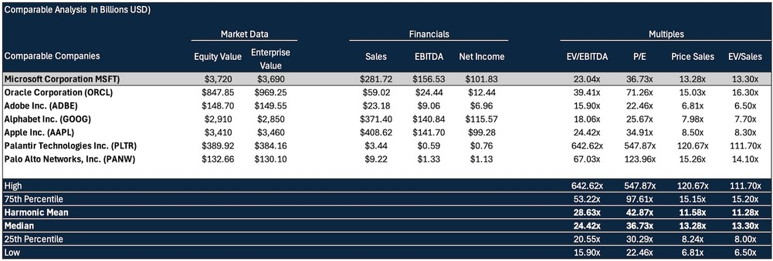
Equity Research Report
Valuation
Microsoft Corporation

(
NASDAQ:MSFT
)

September – October: Between September and October, Microsoft’s shares opened at $418 and closed at $406, trading within a high of $442 and a low of $401. In September, the company announced a 10 percent increase in its quarterly dividend and authorised a $60 billion share repurchase programme on 16 September, followed two days later by the launch of a $30 billion AI infrastructure fund in partnership with BlackRock. These announcements lifted sentiment and helped the stock reach its monthly high of $442. On 30 October, Microsoft reported first-quarter results with revenue of $65.6 billion (+16% YoY), net income of $24.7 billion (+11% YoY), and Microsoft Cloud revenue up (+22% YoY). The strong operational performance was overshadowed by guidance indicating higher AI infrastructure costs and a more conservative cloud outlook, which drove the shares down about 6% in a single session, bringing them to a monthly low of $401. This marked the steepest one-day decline since October 2022.
November – January: Between November 2024 and January 2025, Microsoft’s shares opened at $409 and closed at $415, trading within a high of $456 and a low of $406. In November, the company held Ignite 2024 (19–21 November), where it introduced AI-driven Copilot functionality, autonomous AI agents, and new custom data-centre chips. In December, the Annual Shareholders Meeting (10 December) reiterated Microsoft’s long-term AI and cloud strategy, with the shares reaching their monthly high of $456 before closing at $421. On 29 January, Microsoft reported Q2 FY25 results with revenue of $69.6 billion (+12% YoY), net income of $24.1 billion (+10% YoY), and Microsoft Cloud revenue of $40.9 billion (+21% YoY). Despite the strong numbers, weaker Azure growth guidance and elevated AI infrastructure spending weighed on sentiment, causing the shares to fall to a monthly low of $406 after hours before stabilising at $415 by monthend.
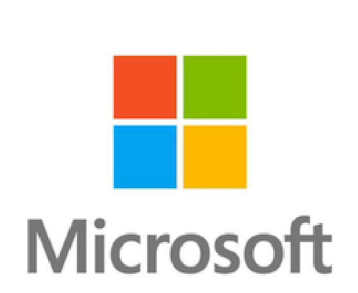
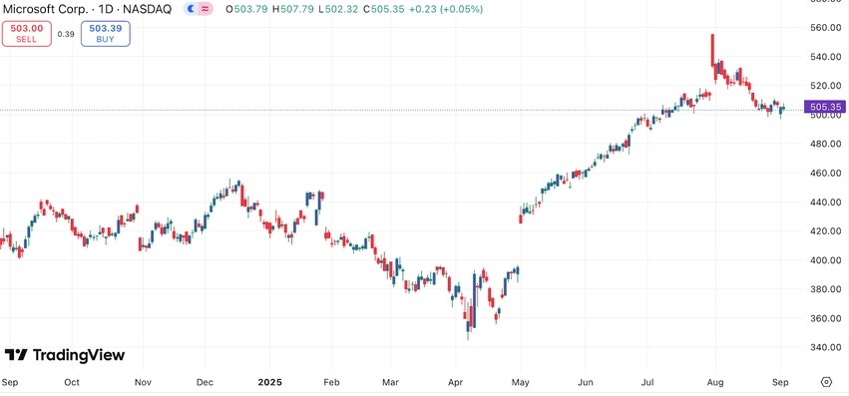
February – March: Between February and March 2025, Microsoft’s shares opened at $412 and closed at $375, trading within a high of $419 and a low of $367. In February, the stock faced renewed pressure as concerns around slowing Azure growth and elevated AI capital expenditure lingered following January’s earnings. Additional caution emerged after reports that Microsoft had cancelled several AI data-centre leases, and the shares declined to a monthly low of $387 before finishing at $397. In March, sentiment weakened further amid broader market volatility and fading enthusiasm for AI investment, with the stock falling to a monthly low of $367 and closing at $375, its lowest level since late 2023.
Price Movement Analysis
Equity Research Report
Microsoft Corporation

(
NASDAQ:MSFT
)
Chart Appendix
April – June: Between April and June 2025, Microsoft’s shares opened at $375 and closed at $497, trading within a high of $501 and a low of $345. In April, the shares reached a monthly low of $345 before closing at $395, as investors awaited the company’s Q3 FY25 earnings at month-end. On 30 April, Microsoft reported Q3 FY25 results with revenue of $72.0 billion (+13% YoY), net income of $26.5 billion (+15% YoY), and Microsoft Cloud revenue of $42.4 billion (+23% YoY). The results exceeded expectations and drove a post-earnings rally of more than 6% in after-hours trading. The momentum carried into May, where the shares reached a monthly high of $463 before closing at $460. Sentiment was supported by the Build 2025 developer conference (19–22 May), where Microsoft announced new AI-powered Copilot features, Windows 11 enhancements, and progress on proprietary AI models. In June, Microsoft announced a commitment to invest $80 billion in AI infrastructure and data centres, alongside international expansion projects, which underpinned further gains. The stock advanced through the month, reaching a monthly high of $501 and closing at $497.
July – August: Between July and August 2025, Microsoft’s shares opened at $496 and closed at $507, trading within a high of $555 and a low of $499. On 2 July, management announced workforce reductions of roughly 9,000 employees, including closures of several Xbox Game Studios projects, as part of a broader cost realignment to support AI infrastructure investment. Later in the month, CEO Satya Nadella acknowledged the disruption in a company-wide memo, describing the transition to AI operations as “messy” while reiterating Microsoft’s long-term focus on security and quality. On 31 July, the company reported Q4 FY25 results, delivering revenue of $74.9 billion (+11% YoY), net income of $27.8 billion (+13% YoY), and Microsoft Cloud revenue of $43.7 billion (+20% YoY). The results, supported by resilient Azure demand and an elevated capex outlook above $30 billion, drove the shares up approximately 8% in a single session and to a monthly high of $555. In August, the shares traded lower, consolidating within a range before closing the period at $507.

Written by Aaron Siby AP Capital Research

Microsoft Corporation is a global technology leader, with dominant market positions in cloud computing, productivity software, operating systems, and artificial intelligence. Its diverse business model, robust financial performance, and consistent innovation have underpinned its long-term success. However, despite its strengths, Microsoft faces several risks that could impact its future growth, valuation, and resilience. These include macroeconomic factors, evolving industry dynamics, regulatory scrutiny, and company-specific challenges.

1. Economic and Market Risks
Microsoft’s performance is influenced by global economic conditions, particularly enterprise and government IT spending. In periods of economic slowdown or recession, businesses often delay or reduce their technology investments, which can weigh on demand for Microsoft’s cloud services, enterprise software, and devices.
Moreover, as interest rates remain elevated in many markets, capital expenditure across industries may tighten, slowing growth for Azure and other cloud infrastructure projects. Currency volatility, especially with significant exposure to European and Asian markets, also poses risks to revenue and profit translation.

2. Competitive and Technological Risks
While Microsoft holds a strong competitive position, it operates in highly dynamic and competitive markets. In cloud computing, it faces intense rivalry from Amazon Web Services (AWS) and Google Cloud. In AI, competition from Nvidia, Open AI collaborators, and emerging startups could challenge its innovation pace and cost efficiency.
Rapid technological change also means Microsoft must continuously invest in R&D to stay ahead. Failure to lead in key areas like generative AI, cybersecurity, or developer ecosystems could erode market share and growth potential. Furthermore, overdependence on Azure and Microsoft 365 for growth creates vulnerabilities if these platforms underperform or lose traction.

3.Regulatory and Antitrust Risks
Microsoft is increasingly under scrutiny from global regulators, particularly in the U.S. and European Union. The company’s recent $68.7 billion acquisition of Activision Blizzard (closed in late 2023) faced extensive antitrust reviews. Ongoing regulatory pressure may limit Microsoft’s M&A strategy or impose structural remedies affecting its operations.
Additionally, Microsoft’s dominance in cloud computing and productivity software has prompted calls for market competition reviews. New antitrust actions, data localization laws, or digital market regulations could create operational friction and legal costs.

4. Geopolitical and Global Operational Risks
With operations and clients in nearly every country, Microsoft is exposed to geopolitical tensions and international trade dynamics. Regulatory risks in China, sanctions affecting cloud infrastructure deployments in restricted regions, or broader USChina tech decoupling could limit access to key markets and suppliers.
Heightened geopolitical instability, especially in Eastern Europe, the Middle East, and parts of Asia, also poses risks to business continuity, employee safety, and regional data compliance.

5. Technology and Cybersecurity Risks
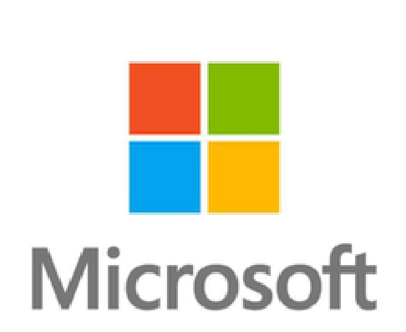
As a leading cloud service provider, Microsoft is a high-value target for cyberattacks. Any major breach affecting Azure, Microsoft 365, or its enterprise customers could result in regulatory investigations, litigation, and reputational damage. Recent incidents include the July 2023 Storm-0558 intrusion which highlights vulnerabilities in even advanced security infrastructures. Data privacy laws such as the EU’s GDPR, U.S. state laws, and evolving regulations in Asia require constant compliance updates. Missteps or failures in managing personal or enterprise data can lead to fines, customer loss, or product restrictions.
Price Movement Analysis
Investment Risks
Equity Research Report
Microsoft Corporation (NASDAQ:MSFT)

6. Operational and Strategic Risks
Microsoft’s recent transition toward AI-centric operations has involved significant strategic shifts. In July 2025, the company announced workforce reductions (~9,000 employees) and project closures across Xbox Game Studios to reallocate resources toward AI infrastructure. While these moves support long-term efficiency, they also pose short-term risks to employee morale, product continuity, and brand perception,particularly in consumer-facing segments like gaming.
The company’s elevated capital expenditure outlook (over $30 billion annually) for AI and cloud infrastructure adds pressure to deliver consistent revenue and margin expansion. A misalignment between spending and returns could lead to investor disappointment or reduced operational flexibility.

7. ESG and Reputational Risks
Investors are increasingly attentive to Microsoft’s environmental, social, and governance (ESG) commitments. While the company has made notable sustainability pledges (including being carbon negative by 2030), falling short of these goals or inconsistencies in reporting could undermine investor trust or result in exclusion from ESG-focused portfolios.
Social risks such as workplace diversity, ethical AI development, and responsible sourcing of raw materials for hardware products (e.g., Surface devices, Xbox) are under growing scrutiny. Any controversies in these areas could damage brand reputation and employee engagement.

8. Litigation and Legal Exposure
Microsoft is exposed to legal risks arising from intellectual property disputes, contract litigation, regulatory investigations, and consumer protection claims. The company also faces scrutiny over its role in digital advertising (via LinkedIn), gaming practices, and software licensing. These issues can result in legal costs, penalties, and compliance burdens, affecting financial results and public perception.

Conclusion
Microsoft’s dominant market position, broad diversification, and strong financial profile make it a leading player in the global tech industry. However, it is not without significant investment risks. Macroeconomic pressures, intensifying competition, evolving regulatory frameworks, and geopolitical uncertainty could all impact the company's long-term performance. Additionally, the shift toward AI, while promising, introduces operational complexity and strategic execution risk. Cybersecurity threats, ESG pressures, and legal liabilities further add layers of uncertainty. Investors should consider these factors carefully when evaluating Microsoft’s long-term value, particularly in a rapidly changing technological and regulatory environment.

Written by Devraj Roy AP Capital Research
Equity Research Report Disclaimer and Authors

DEVRAJ ROY AARON SIBY PIOTR AMBROZEWSKI
Analyst Analyst Analyst
dr00510@gmail.com as04492@gmail.com ashrafulenam75@gmail.com

Disclaimer

This report is produced by university student members of AP Capital Research (APCR). This is not financial advice. All material presented in this report, unless otherwise specified, is under the copyright of APCR. None of the material, nor its content, nor any copy of it, may be altered in any way without the prior express written permission and approval of APCR. All trademarks, service marks, and logos used in this report are trademarks or service marks of APCR. The information, tools and materials presented in this report are for information purposes only and should not be used or considered as an offer or a solicitation of an offer to sell buy or subscribe to securities or other financial instruments. APCR has not taken any measures to ensure that the opinions in the report are suitable for any particular investor. This report does not constitute any form of legal, investment, taxation, or accounting advice, nor does this report constitute a personal recommendation to you. Information and opinions presented in this report have been obtained from or derived from sources that APCR believes to be reliable and appropriate but APCR makes no representation as to their accuracy or completeness. APCR accepts no liability for loss arising from the use of the material presented in this report. Due attention should be given to the fact that this report is written by university students. This report is not to be relied upon in substitution for the exercise of independent judgment. APCR may have issued in the past and may issue in the future other communications and reports which are inconsistent with, and reach different conclusions from, the information presented in this report. Such communications and reports represent the different assumptions, views, and analytical methods of the analysts who prepared them. APCR is not obligated to make sure that such communications and reports are brought to the attention of any recipient of this report. This report and all other publications by APCR do not constitute the opinion of the University of Surrey, nor any governing or student body or department under the University aside from APCR itself. This report may provide the addresses of or contain hyperlinks to, websites. Except to the extent to which the report refers to APCR website material, APCR has not reviewed any such website and takes no responsibility for the content contained therein. Such addresses or hyperlinks (including addresses or hyperlinks to APCR’s website material) are provided solely for your own convenience and information and the content of any such website does not in any way form part of this Report. Accessing such website or following such link through this report shall be at your own risk

About AP Capital Research

AP Capital Research is a University of Surrey and EFS-affiliated student-led research group, with the sole purpose of providing greater clarity of financial markets. Accomplished through the creation of weekly market insights, detailing the macroeconomic factors driving global markets and industries
Named after the University of Surrey's Austin Pearce building, we thought it was only right to give credit to the place which truly ignited our immersion into economics and finance, and more specifically, our passion for understanding financial markets.

